بسم الله الرحمن الرحیم ۔ اللهم صل علی سیدنا محمد و آله و صحبه و سلم
Pass Mark:
60/100
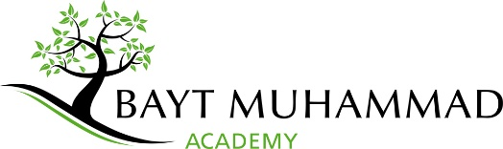

BOOK/TOPIC TITLE – YEAR #
Mid-Year Exam – Monday 14th January 2023
All questions must be answered. Total marks are 100. Pass mark is 60.
Please write your name and date clearly. Begin by reciting Bismillaah and Salawaat.
Read each question carefully and check through your answers before submission.

- Please enter the question here followed by the marks in brackets thereafter (10 Marks)

